বাংলাদেশ বিদ্যুৎ উন্নয়ন বোর্ড

Installed Capacity of BPDB Power Plants as on October 2025
Link : https://misc.bpdb.gov.bd/power-generation-unit

Electric Vehicle Charging Guideline
https://file-khulna.portal.gov.bd/uploads/d07c3114-12a6-4ebe-8fa0-460e27018e82//671/5a0/75b/6715a075bfbf0518800500.pdf

Lithium Battery Imports In Bangladesh - Market Size & Demand Based On Import Trade Data
https://www.volza.com/p/lithium-battery/import/import-in-bangladesh/

BANGLADESH RURAL ELECTRIFICATION BOARD DATE: ^.2.-09-2025 i Directorate of OFFICE OF SUPERINTENDING ENGINEER (ENERGY AUDIT AND TARIFF), BRE8, KHILKHET, DHAKA FOR THE MONTH OF August 2025 MANAGEMENT INFORMATION SYSTEM (MIS) –
https://reb.portal.gov.bd/sites/default/files/files/reb.portal.gov.bd/page/8f29e63c_7bea_4373_be82_923752ffe29a/2025-09-28-06-13-2afcc49611018b3c26b348d2d97fe456.pdf

Affordable Electric Three-Wheeler in Bangladesh: Prospects, Challenges, and Sustainable Solutions
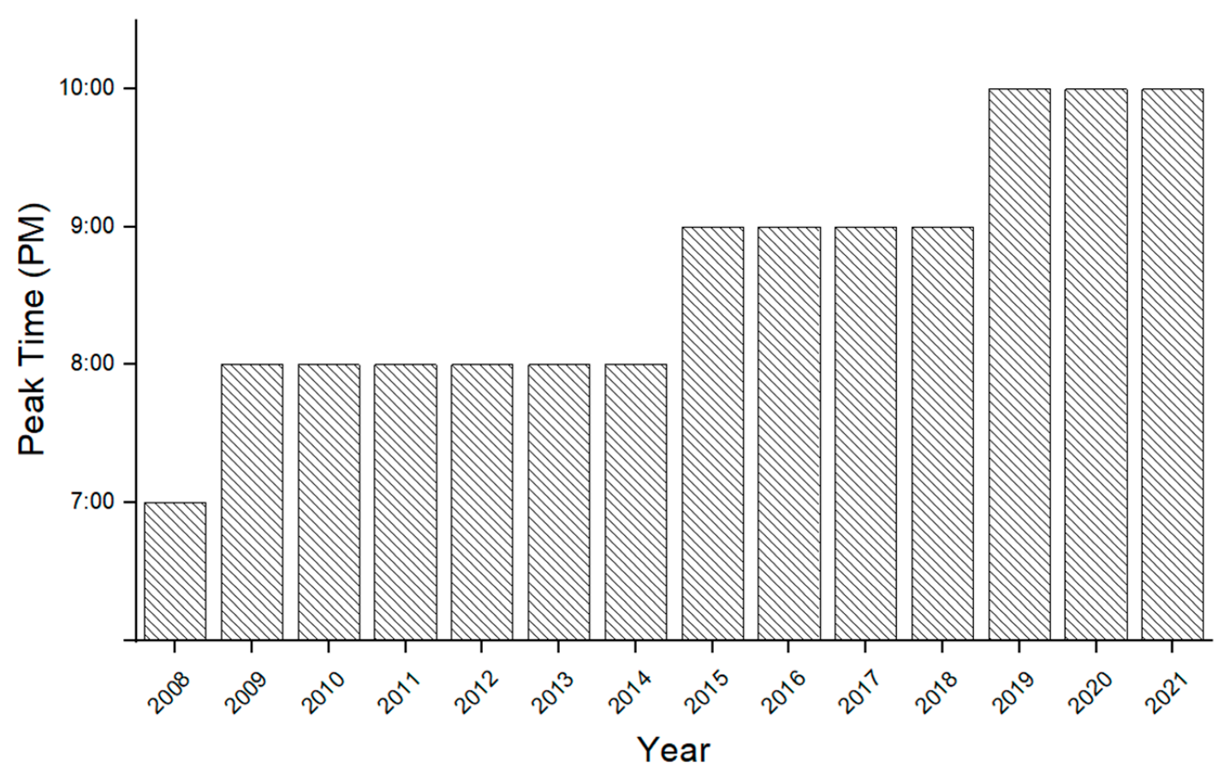

Bangladesh Power System Peak Demand Shaving through Demand Side Management of the Battery Operated Easy Bike Load
https://ieeexplore.ieee.org/document/9068796/metrics#metrics

Electricity final consumption by sector, Bangladesh, 2023

https://www.iea.org/countries/bangladesh/electricity?

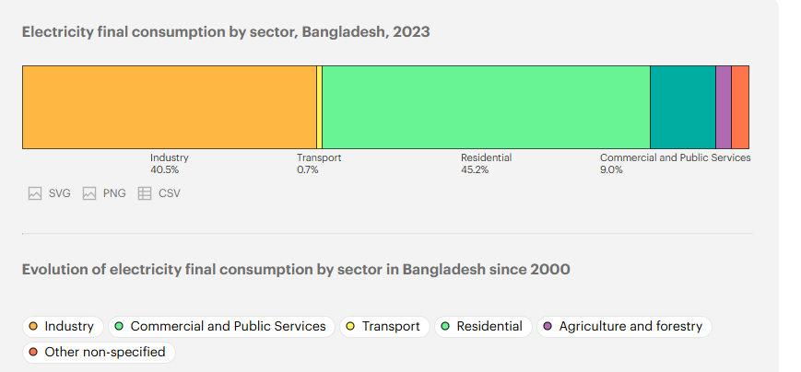

Electricity consumption per capita, Bangladesh 2023
https://www.iea.org/countries/bangladesh/electricity

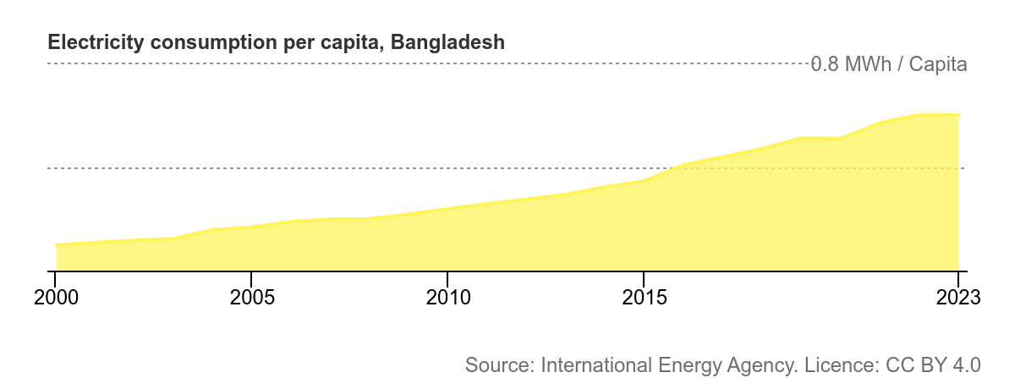

Transport total final consumption by source, Bangladesh, 2023
https://www.iea.org/countries/bangladesh/efficiency-demand

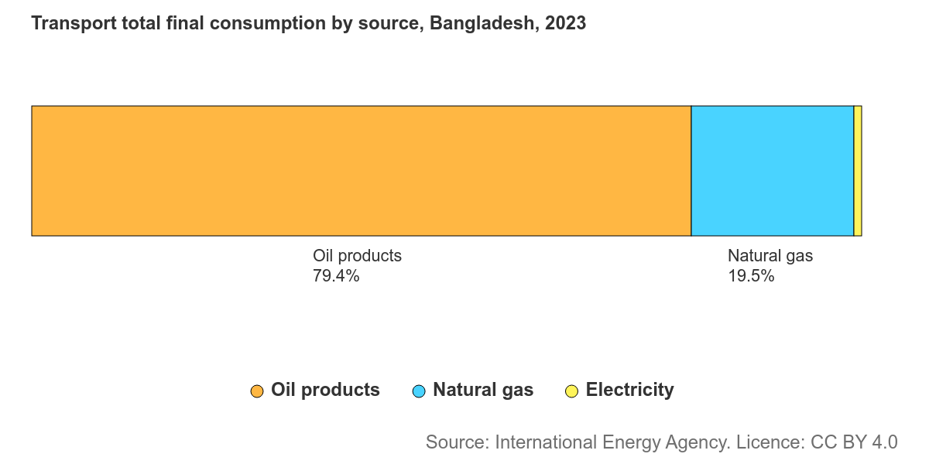

Evolution of transport total final consumption by source in Bangladesh since 2000
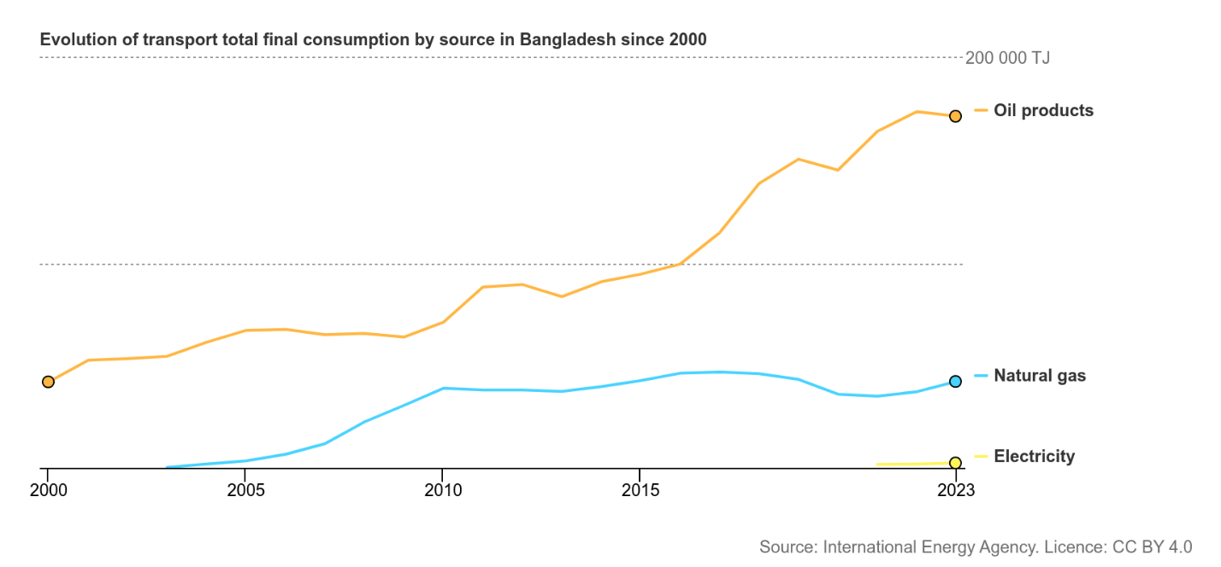

Industry total final consumption by source, Bangladesh, 2023
(energy)

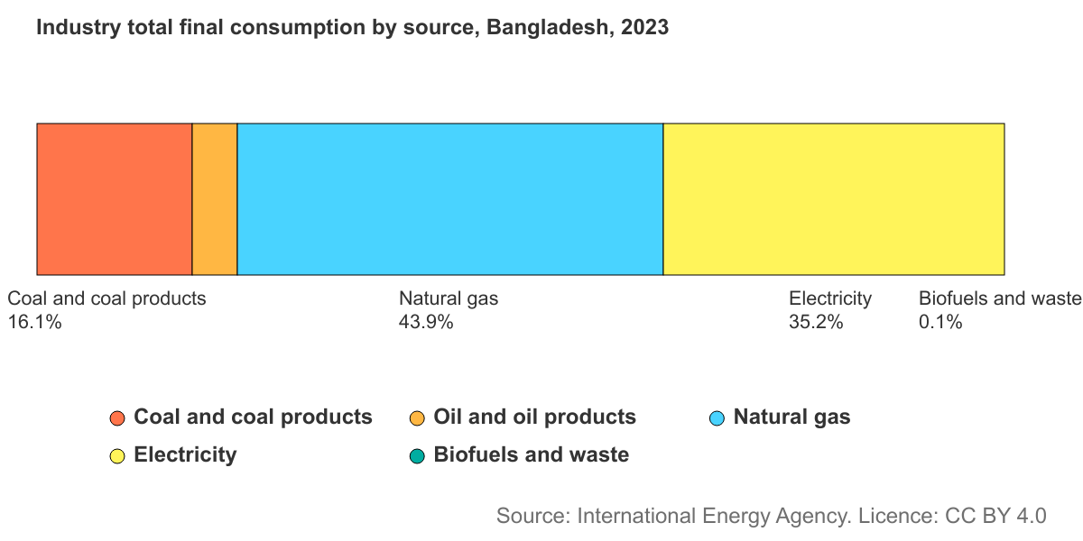

BPDB Annual Report 2022-23
https://bpdb.portal.gov.bd/sites/default/files/files/bpdb.portal.gov.bd/page/771c9a89_a06c_4c2f_9b8c_699d17ed769a/2023-12-20-09-13-bc35a2ac1abda167c7c48437e4dc1061.pdf?utm_source=chatgpt.com

